**Media and Forms Assignment  
OUTPUTS**

Q1**.** 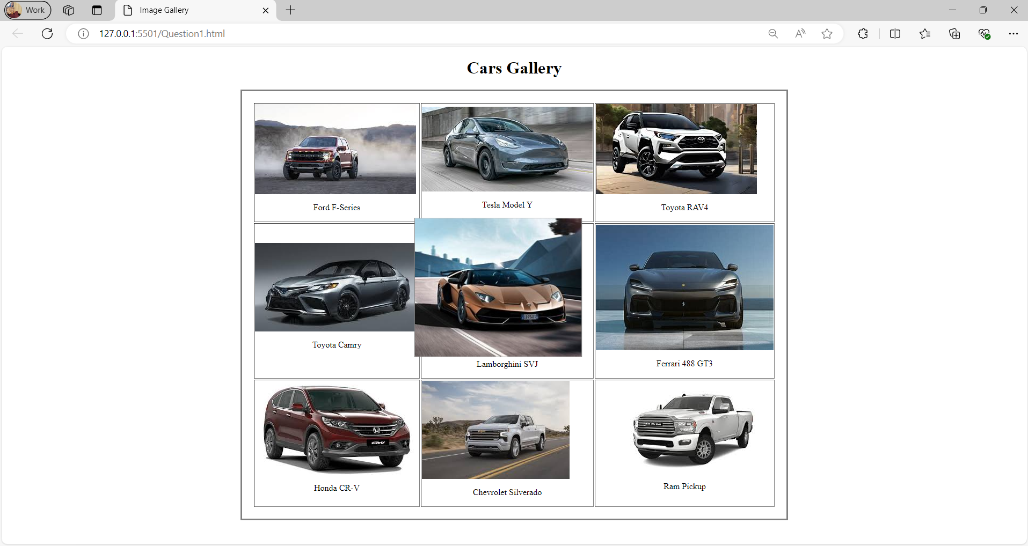  
  
  
Q2.  
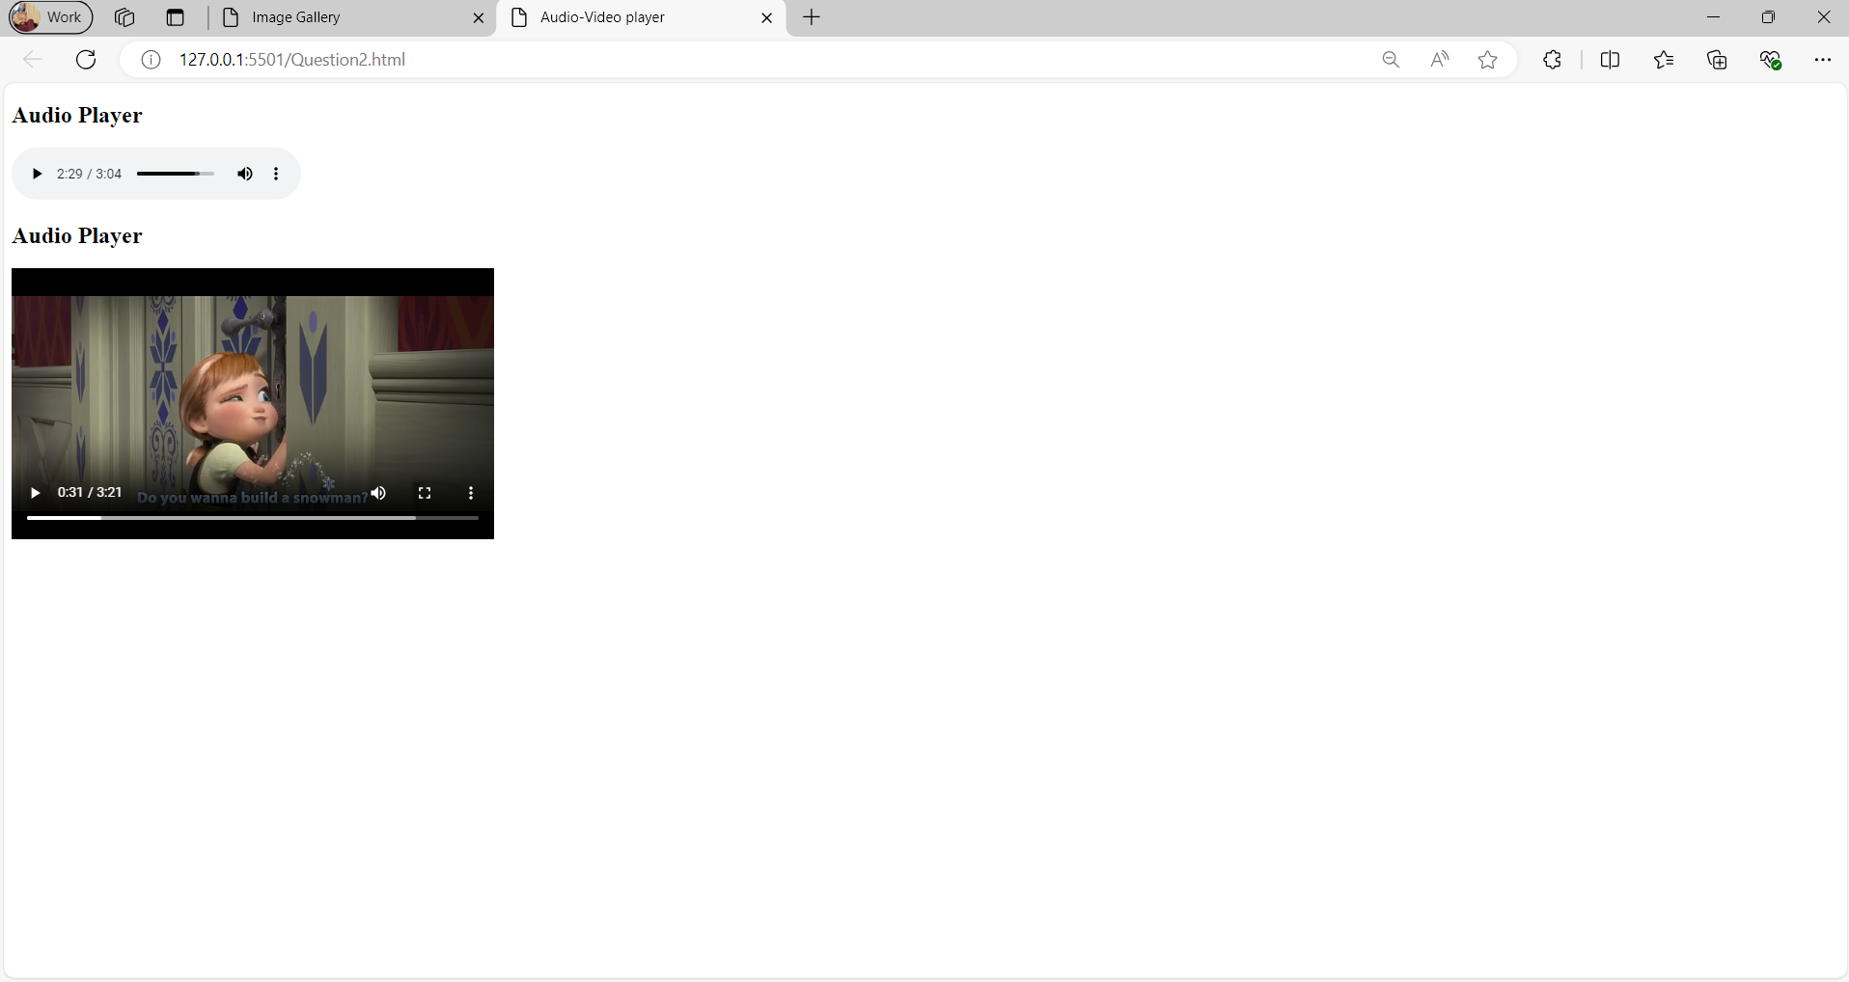  
  
Q3.  
  
Q4.  
  
Q5.  
